**Guidelines for Data Visualization and Analysis Project**

**About the Project:**

In this project, you will be working with a dataset from the Superstore, aiming to answer 30 scenario-based questions through data visualisation and analysis. Your objective is to select the best chart for each question, explain your choice. This project will showcase your proficiency in data visualisation, critical thinking, and effective communication.

**Skills Required:**

* Proficiency in data visualisation concepts and techniques.
* Familiarity with Tableau or a similar data visualisation tool.
* Strong analytical and problem-solving skills.
* Ability to choose appropriate charts based on data characteristics and question requirements.
* Clear and concise communication skills.

**Deliverables:**

* A Google document containing solutions to the scenario based questions including the screenshot of relevant chart picked for each scenario, presented in a concise and well-structured format. Make sure to provide explanations that highlight your problem-solving skills.

**Rubrics for Assessment:**

Question Responses:

* Accuracy and completeness of answers for all 30 questions.
* Clear and concise explanations that address the question's context.

Chart Selection and Explanation:

* Thoughtful rationale for choosing specific chart types.
* Justification based on data characteristics, context, and communication goals.

Creative Enhancements:

* Effective use of creative elements to enhance visualisation quality.
* Enhancements that contribute to better understanding or engagement.

**Note**:

* Duplicate this document and proceed to write your solutions.
* For each scenario and question, provide a justification for the choice of chart type. Explain why it is the best option to visualise the data effectively.
* Attach screenshots of the charts you have created in Tableau for each scenario and question using the Superstore dataset. Label them clearly to match the corresponding questions in the Google Document.
* Submit the duplicated google doc file after completion.

Use these guidelines to structure your data visualisation and analysis project. Remember to maintain consistency in your responses, explanations, and visualisation styles. This project will not only demonstrate your skills but also your ability to effectively communicate complex information through visualisations. Good luck!

**Problem Statement: Choose the Best chart for any 30 scenario based questions from Superstore Dataset.**

Imagine you are a data enthusiast aiming to excel in data visualisation and analysis. In this task, you have been given any 30 scenario-based questions derived from the Superstore dataset, and your objective is to provide insightful answers using appropriate charts. For each question, you need to select a chart that best represents the data, explain why you chose that specific chart, and then proceed to build the chosen chart using Tableau.

Your responses should be succinct, organised, and illustrative of your problem-solving capabilities.

**Dataset Link:**

<https://community.tableau.com/s/question/0D54T00000CWeX8SAL/sample-superstore-sales-excelxls>

**Please keep in mind:**

1. **Answer Completion**: Ensure that you furnish answers for all any 30 questions and build charts for them.
2. **Encouraged Creativity**: Don't hesitate to employ visuals, creative elements, or any other innovative approaches to enhance the quality of your responses.

By completing this task effectively, you'll not only demonstrate your proficiency in data visualisation and analysis but also showcase your ability to effectively communicate complex concepts through both text and charts.

**Good luck!**

**Questions:**

1. Which product categories have the highest total sales in the "Superstore" dataset?  
   **Ans. 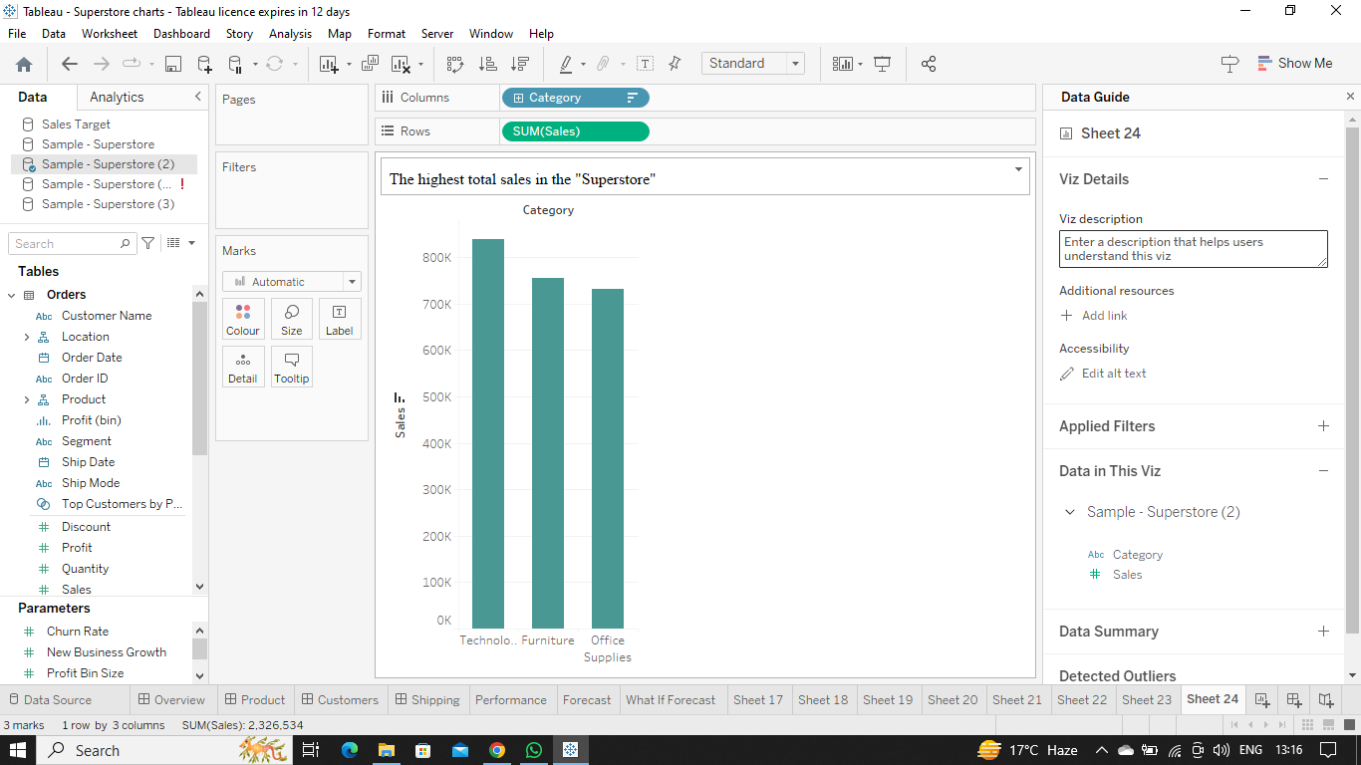  
     
   Explanation:-**To find highest total sales in the dataset we need to compare each category's total sales and for that the best fit chart is **Bar Chart .**Hence , in the above case “Category” : “Technology” has the highest no. of total sales i.e. 839,893.
2. How do the monthly sales amounts change over the course of a year?  
   **Ans.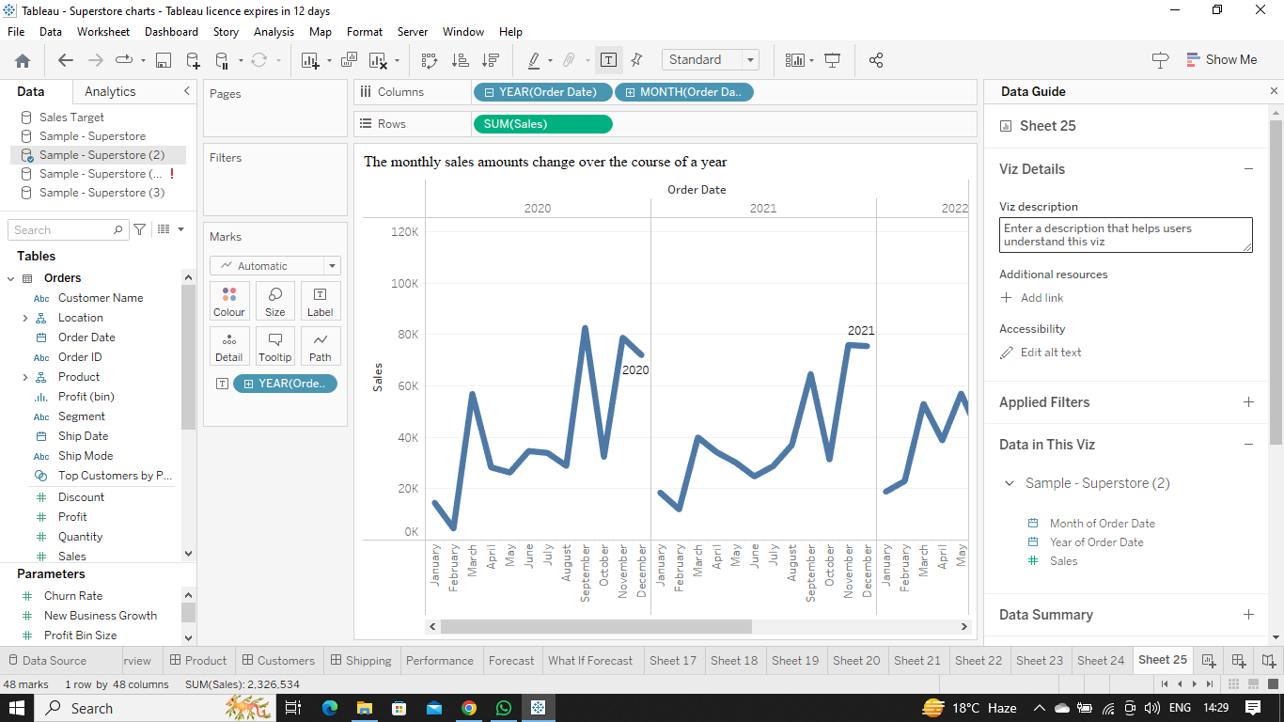  
   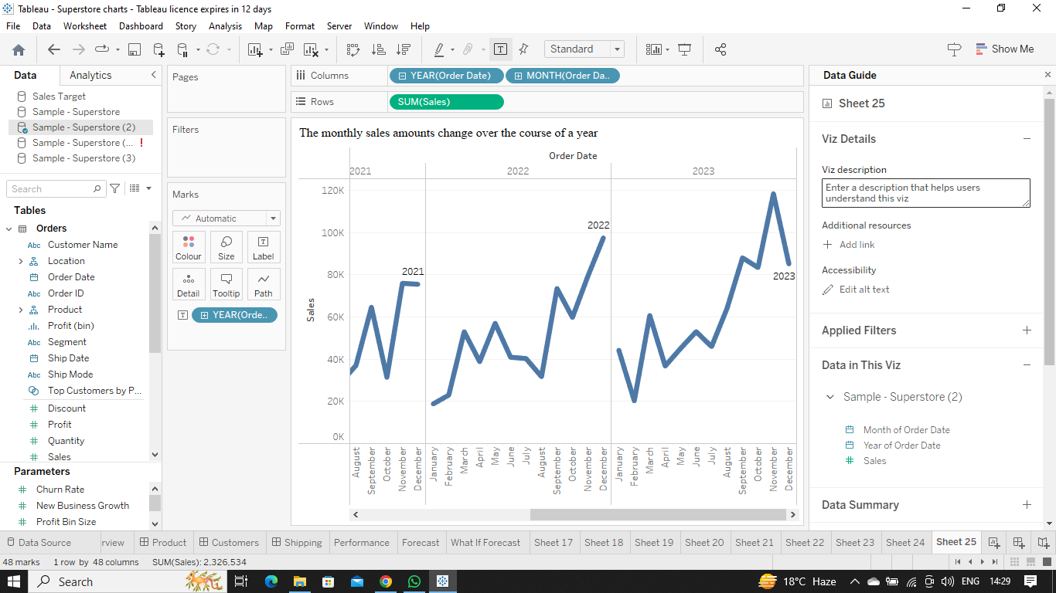  
     
   Explanation:-**To show the monthly sales amounts change over the course of a year we need to show the trend of the sales in every year followed by months and for this the best fit chart is **Line Chart .**
3. How is the total sales amount distributed among different product categories?  
   **Ans.  
   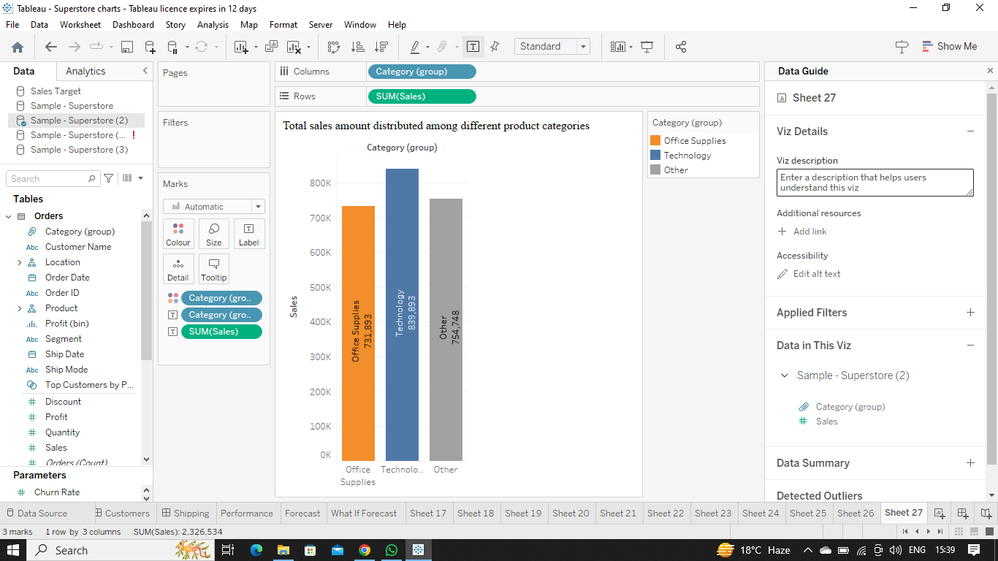  
   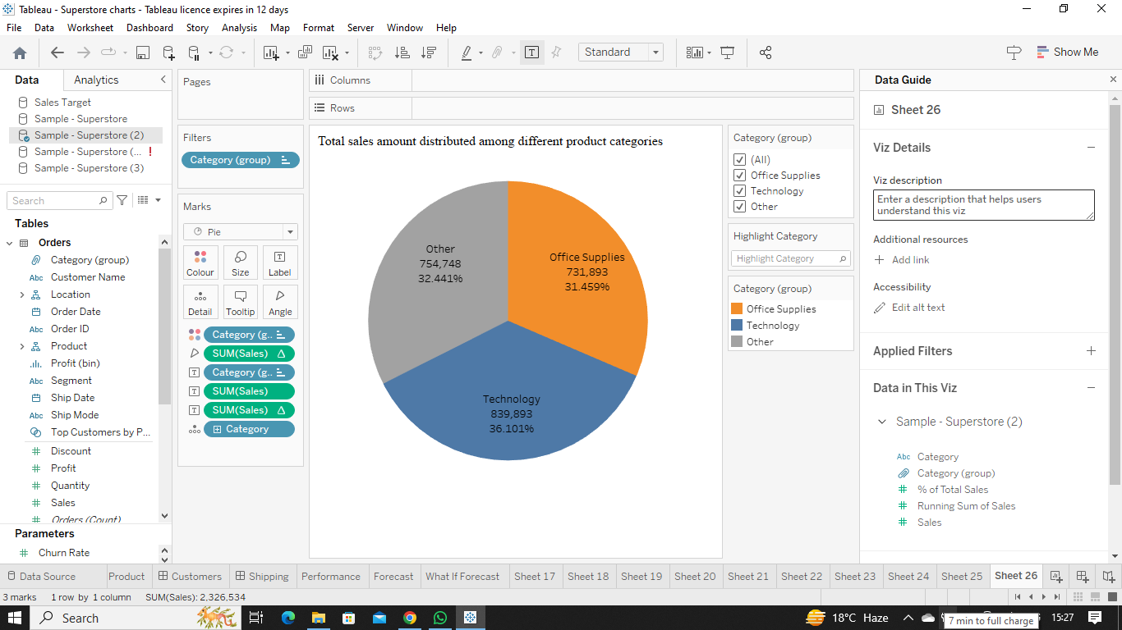  
     
   Explanation:-**To show the total amount distributed among the different product categories we can choose both **Bar Chart and Pie Chart** . For showing total amount distributed in no. we can use **Bar Chart** and for showing total amount distributed in percentage we can use **Pie Chart** .
4. Can we analyze the sales performance of individual customers over time?  
   **Ans.  
   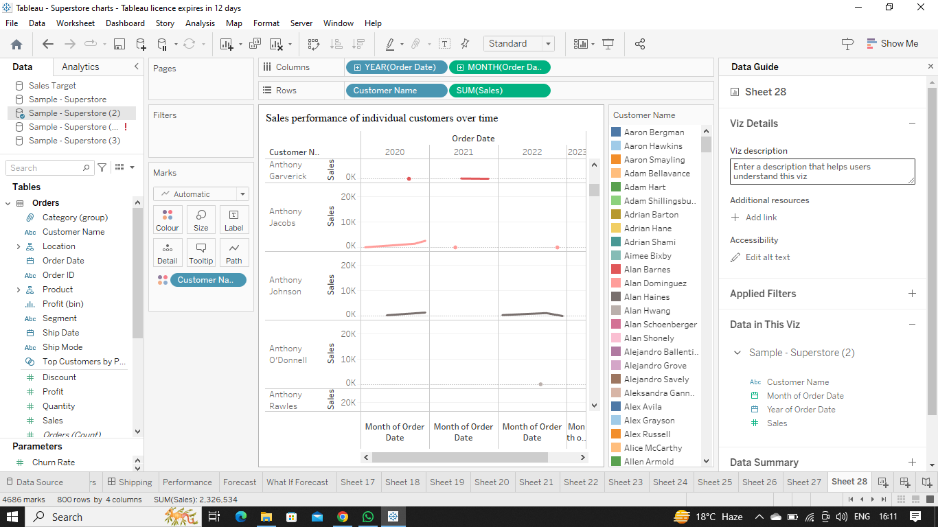  
   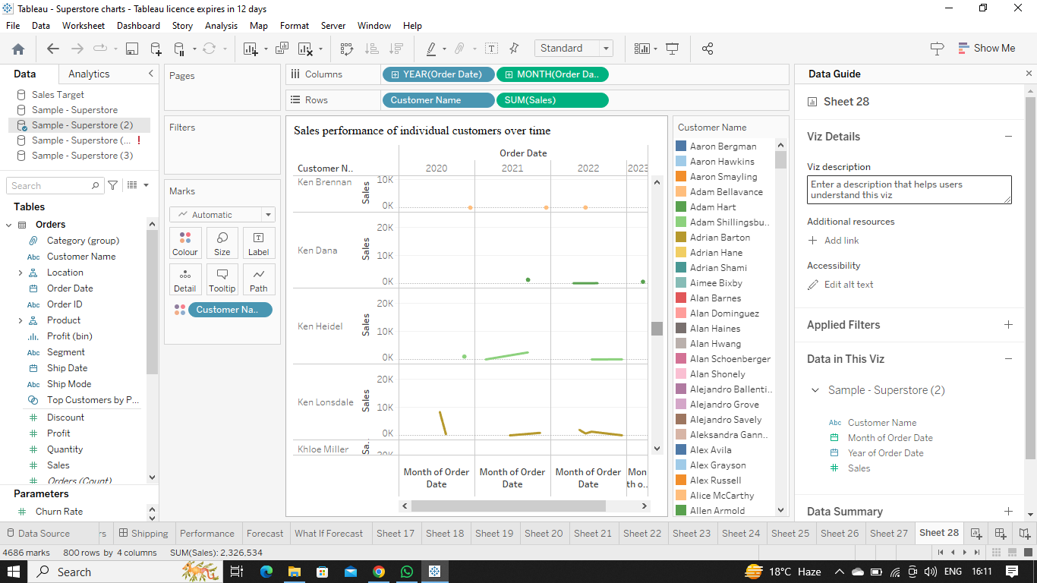  
   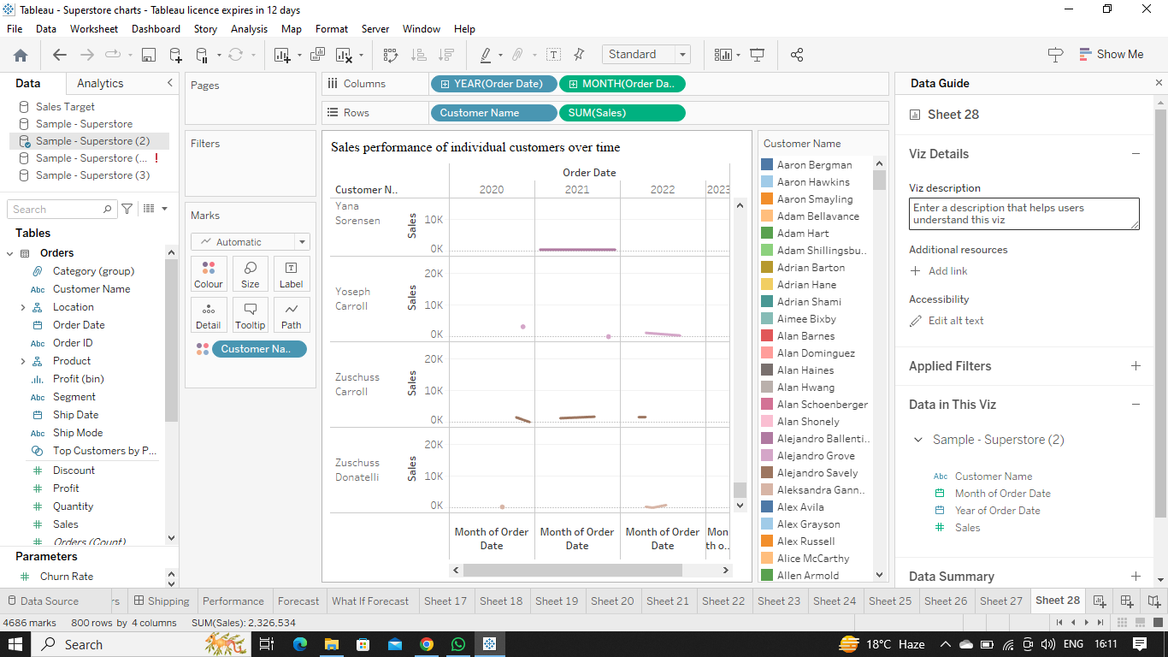  
     
   Explanation:-**Yes, we can analyse the sales performance of individual customers over time . To do this we need to put the order date in Columns and customers name and sales in Rows . Thus, by doing that we can show sales performance of individual customers over time by creating **Line Chart .**
5. How do sales vary based on different days of the week and product categories?  
   **Ans.  
   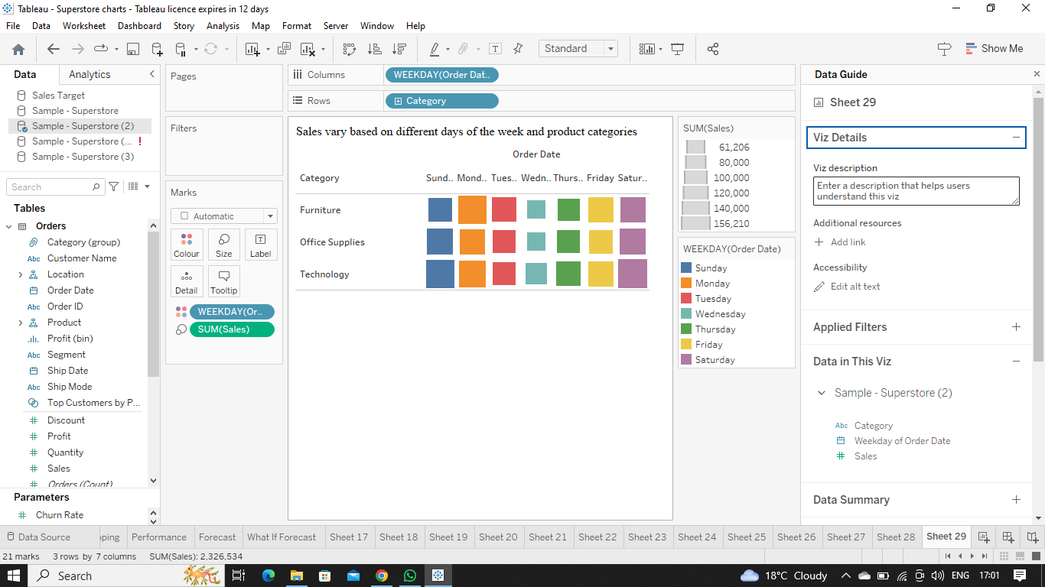  
   Explanation:-**To show sales vary based on different days of the week and product categories we need to put week days in column field and product category in row field and show variation by selecting **Heat Map** .
6. Can we visualise the sales growth of different product categories over time?  
   **Ans.   
   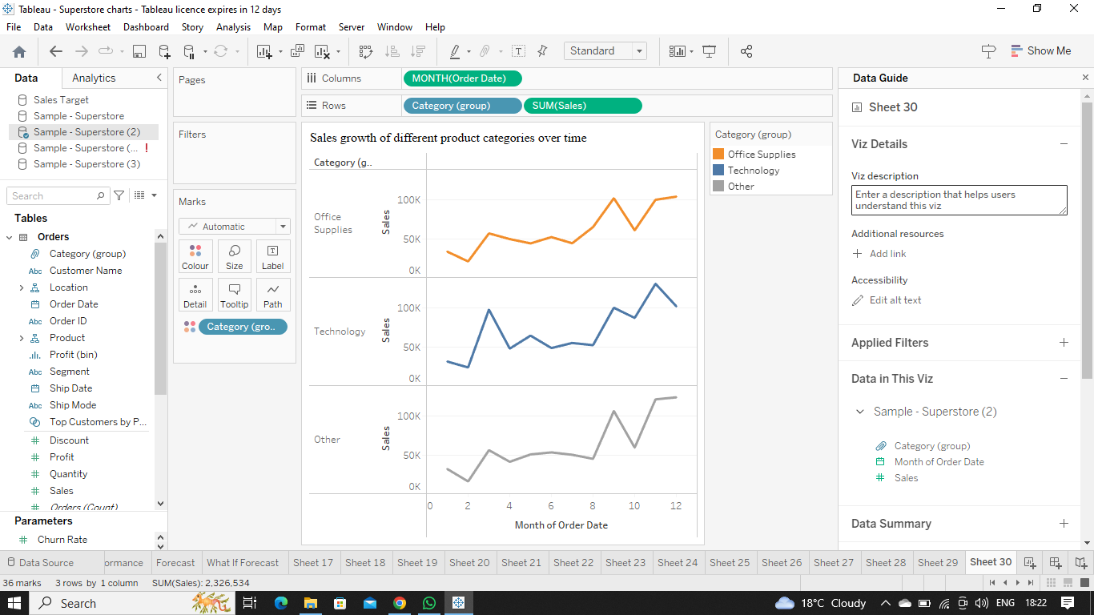  
     
   Explanation:-**Yes, we can visualise the sales growth of different product categories over time . For doing that we need to put months from the order date table in column field and category and sales tables in row field and show growth over time by selecting **Line Chart** .
7. How does the sales distribution vary across different regions in the "Superstore" dataset?  
   **Ans.**   
   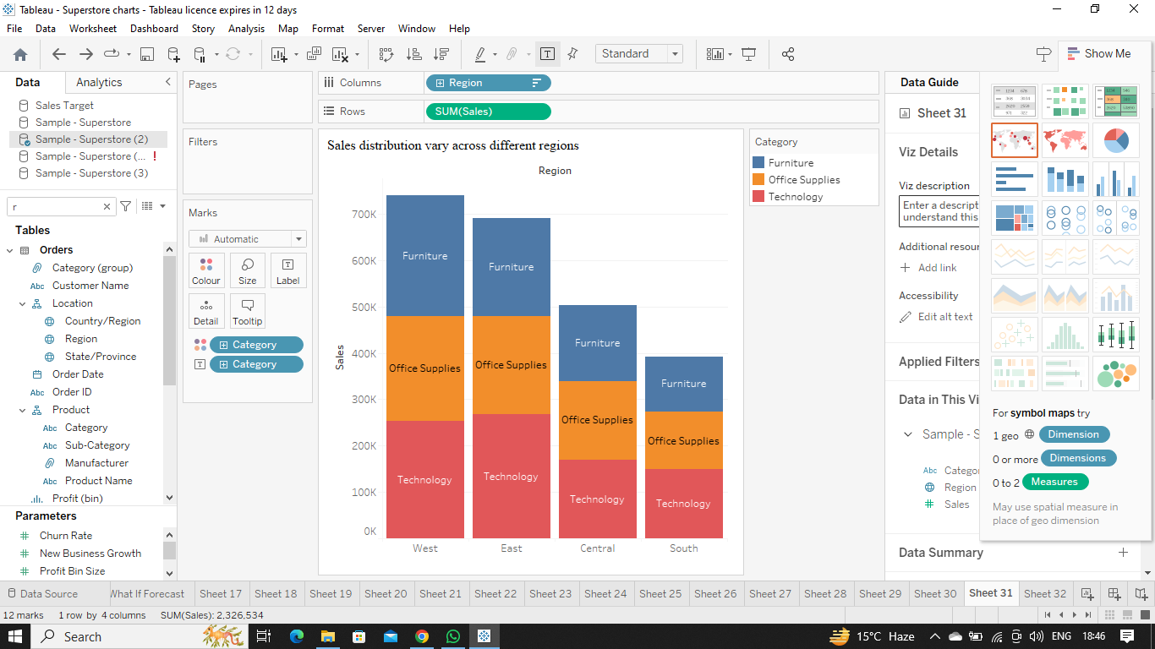  
     
   **Explanation:-**For showing sales distribution vary across different regions we need to drag the region table in column field and sales table in row field and show the variation by selecting **Bar Chart** .
8. Can we visualise the composition of profits across various subcategories within different customer segments?  
   **Ans.  
   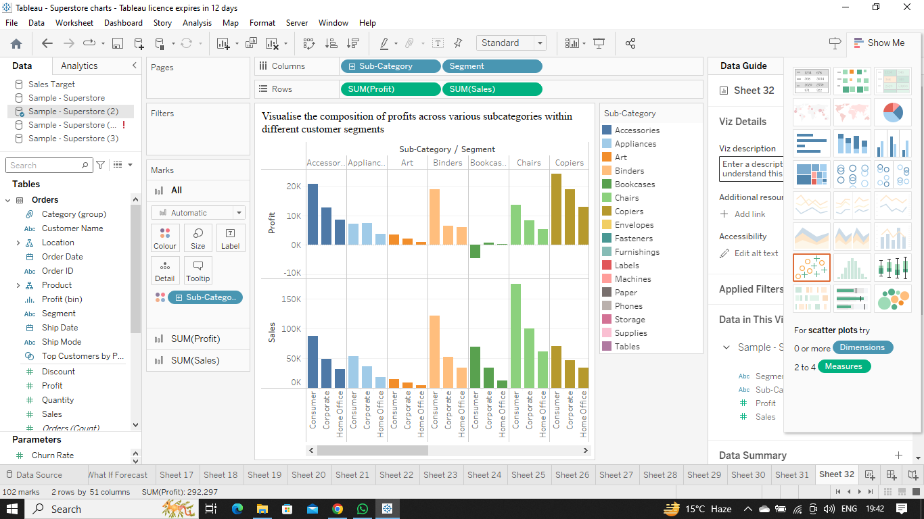  
   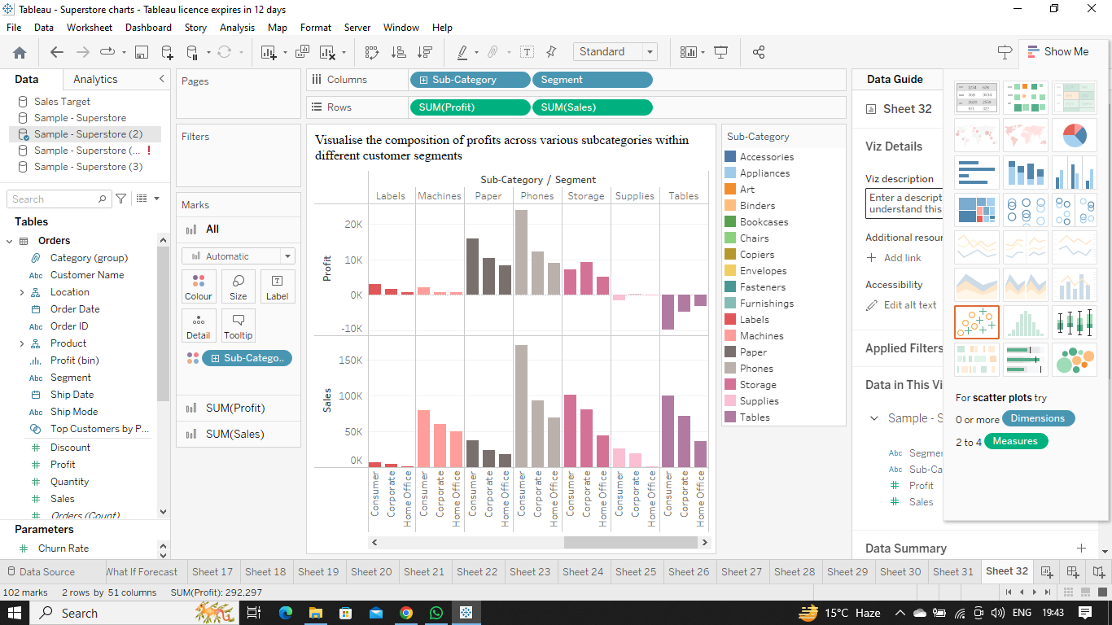**  
     
   **Explanation:-**We can visualise the composition of profits across various subcategories within different customer segments by dragging segment and subcategories table to column field , sales and profit to row field and sub category to colour marks and select **Stacked Bar Chart** .
9. What is the percentage contribution of each region to the overall sales?  
   **Ans.  
   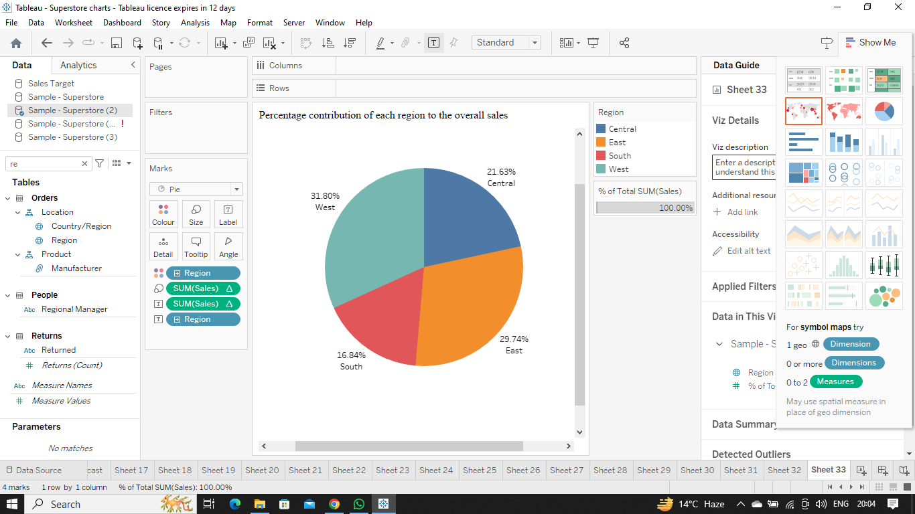  
     
   Explanation:-**To show the percentage contribution of each region to the overall sales drag region table to colour marks, percentage of sales to size marks and region and sales to again in label marks and then to show percentage contribution select **Pie Chart** .
10. Can we visualise the profit margins associated with different shipping modes and customer segments?  
    **Ans.  
    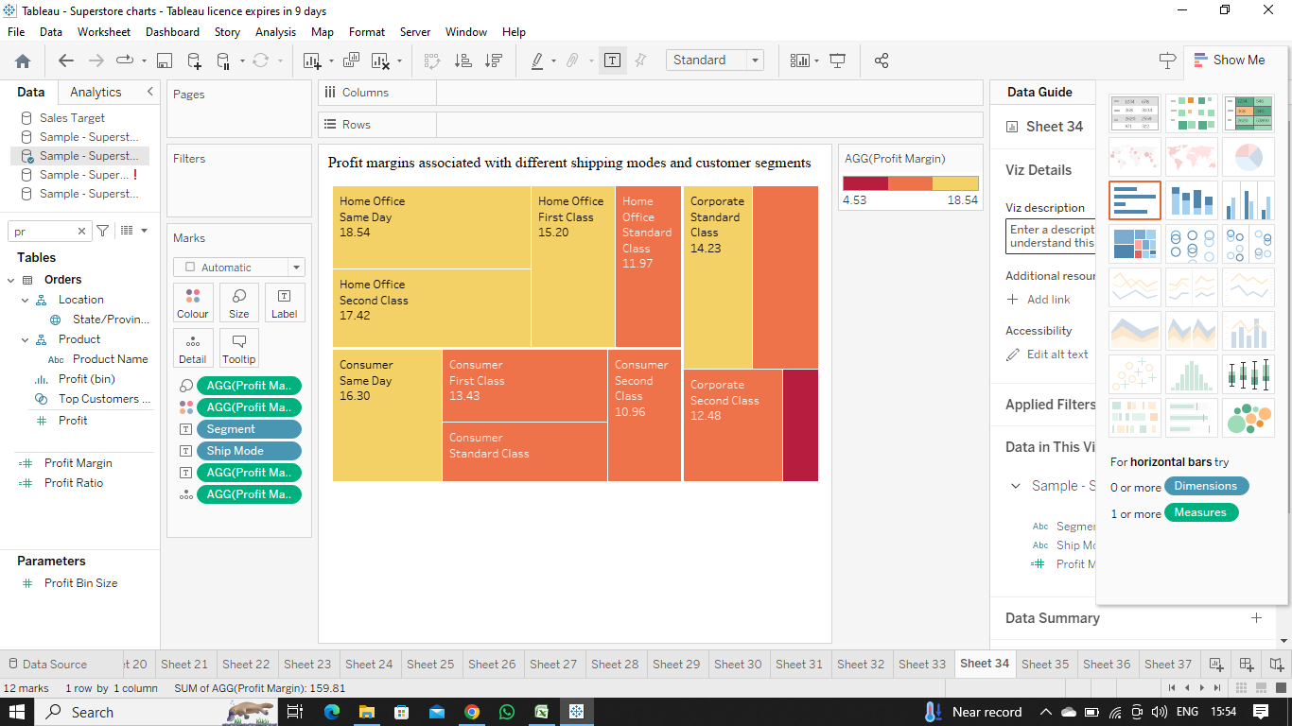  
      
    Explanation:-**Yes , to show profit margins associated with different shipping modes and customer segments we need to create a new calculated field and drag the profit margin to colour marks , profit margin to size marks drag segment , ship mode and profit margin to text marks and the select **Tree Map** .
11. How long does it take to process orders for different product categories?  
    **Ans.**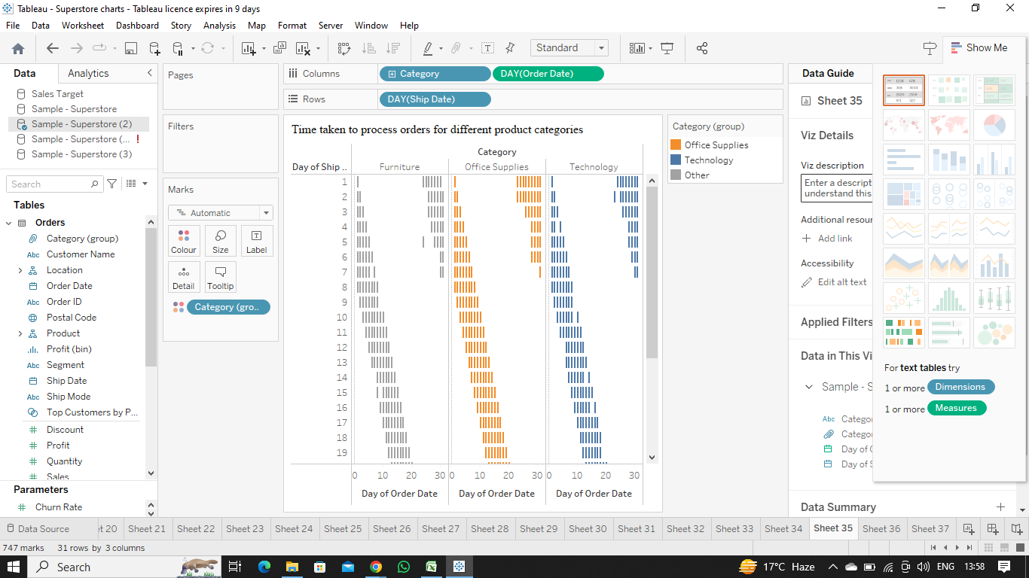  
    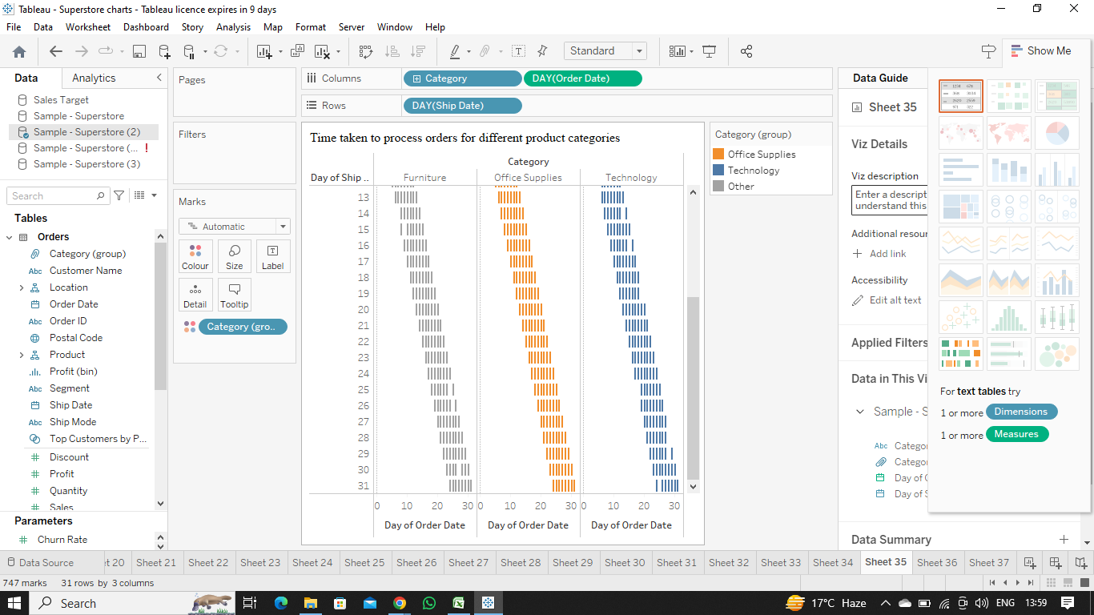  
      
    **Explanation:-**To show the time taken to process the orders of different product categories we have to show the time taken to ship the order and therefore , use **Gantt Chart .**
12. How do discounts affect overall profit?  
    **Ans.  
    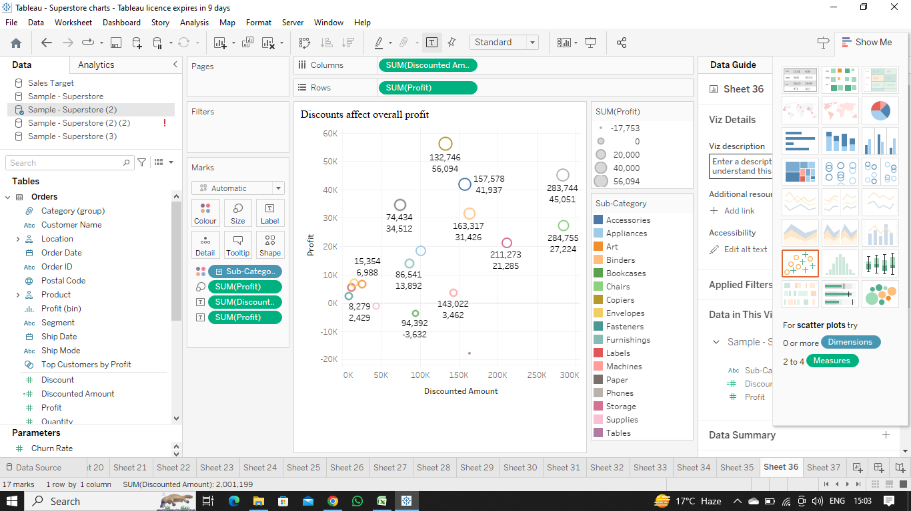  
      
    Explanation:-**To show the effect of discount on overall profit we need to show the comparison between discounted amount and overall profit and for that the best fit graph is **Scatter Plots** .
13. Can we visualise the relationship between product sales and profitability for different product categories?  
    **Ans.  
    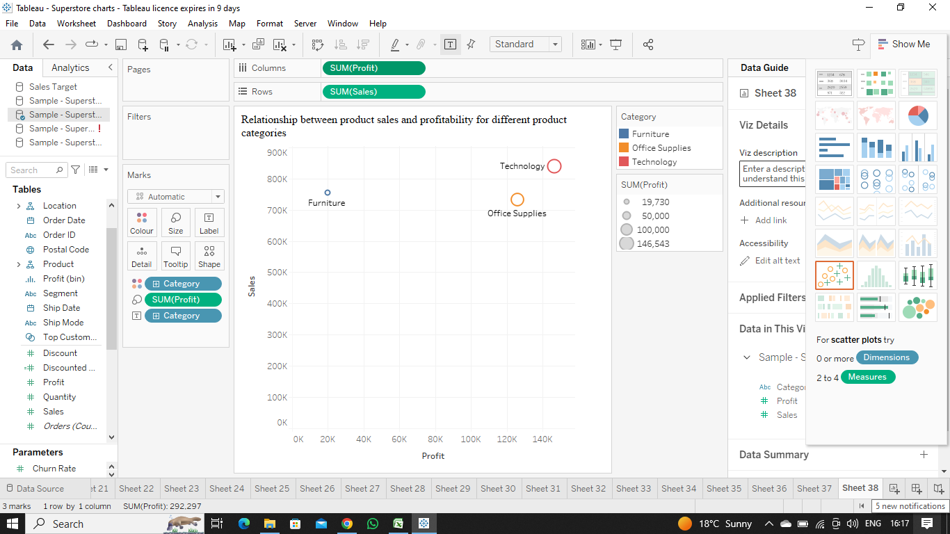  
       
    Explanation:-**To visualise the relationship between product sales and profitability for different product categories we need to find the relationship between two numerical values and for that the best fit chart is **Scatter Chart** .
14. What is the distribution of order quantities for products in the dataset?  
    **Ans.**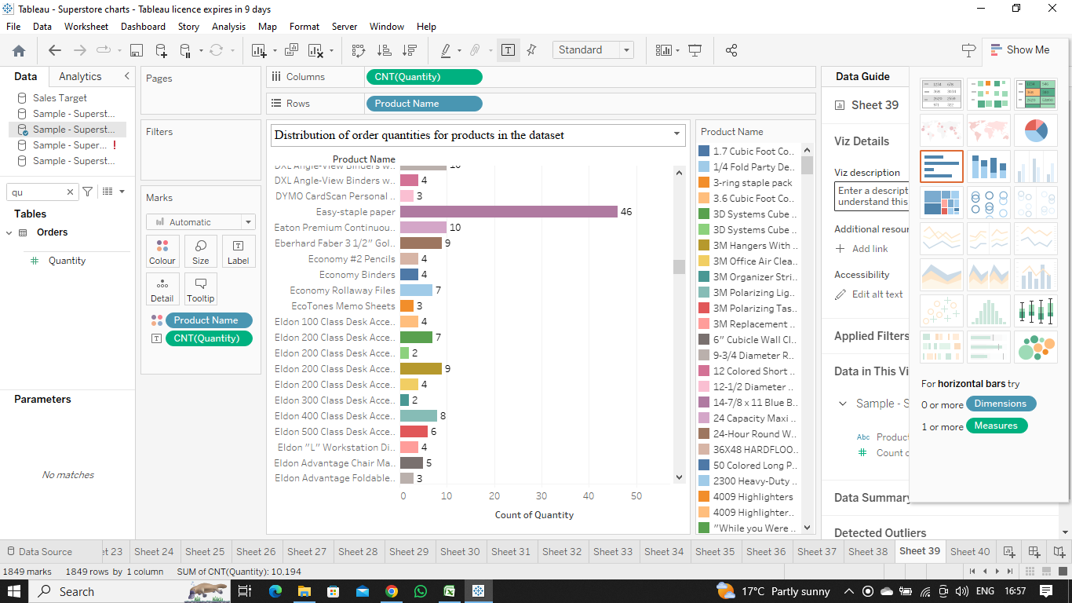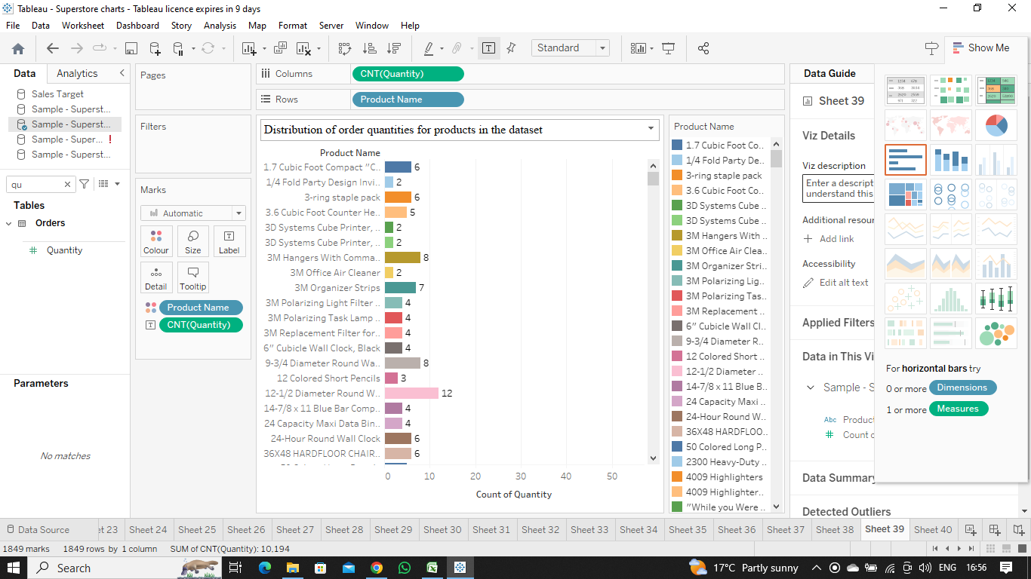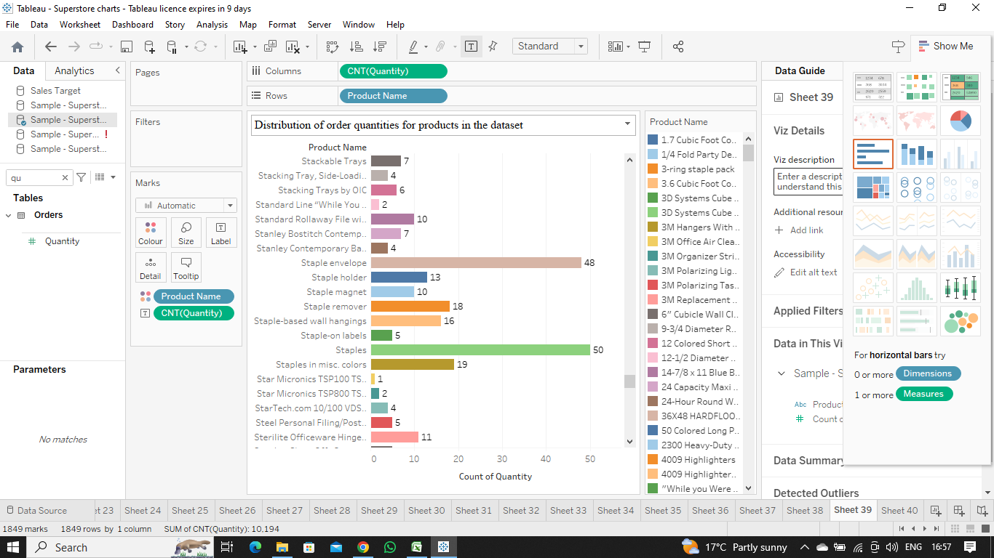  
      
    **Explanation:-**To show the distribution of order quantities for products in the dataset the best way is to compare the quantity distribution and for that the best first chart is **Bar Chart** .
15. How do the profit distributions vary across different product categories?  
    **Ans.  
    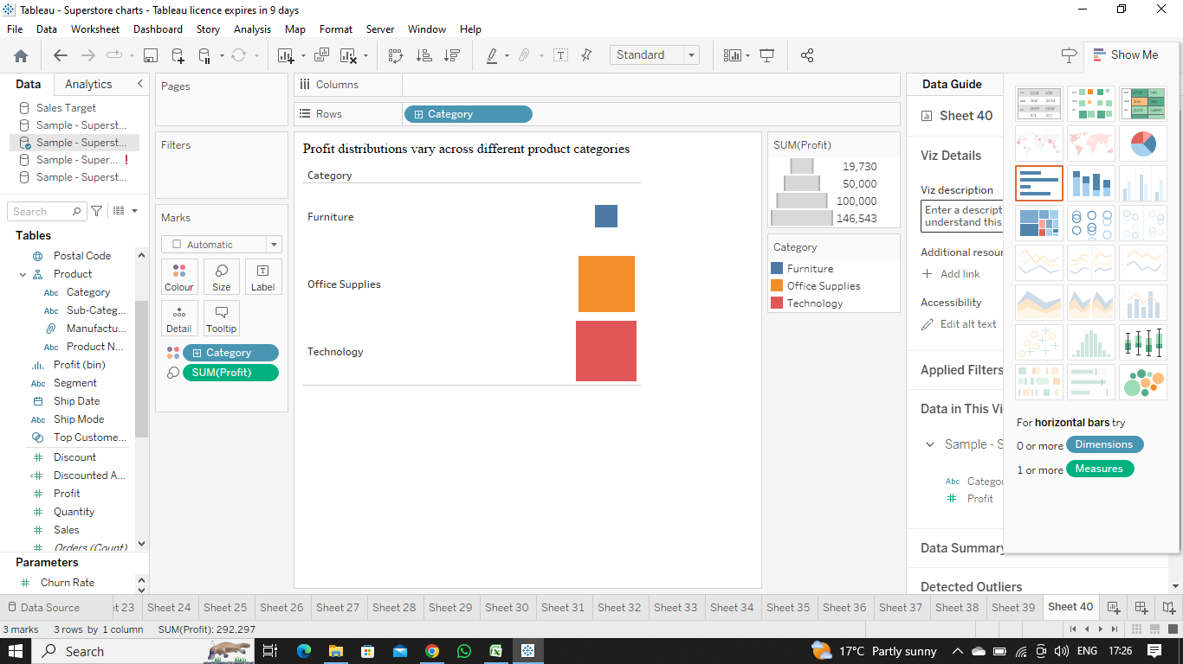  
      
    Explanation:-**To show the profit distributions vary across different product categorieswe need to find variation among categories and for that the best fit chart is **Heat Map** .
16. Can we compare the shipping time distributions for different shipping modes?  
    **Ans.   
    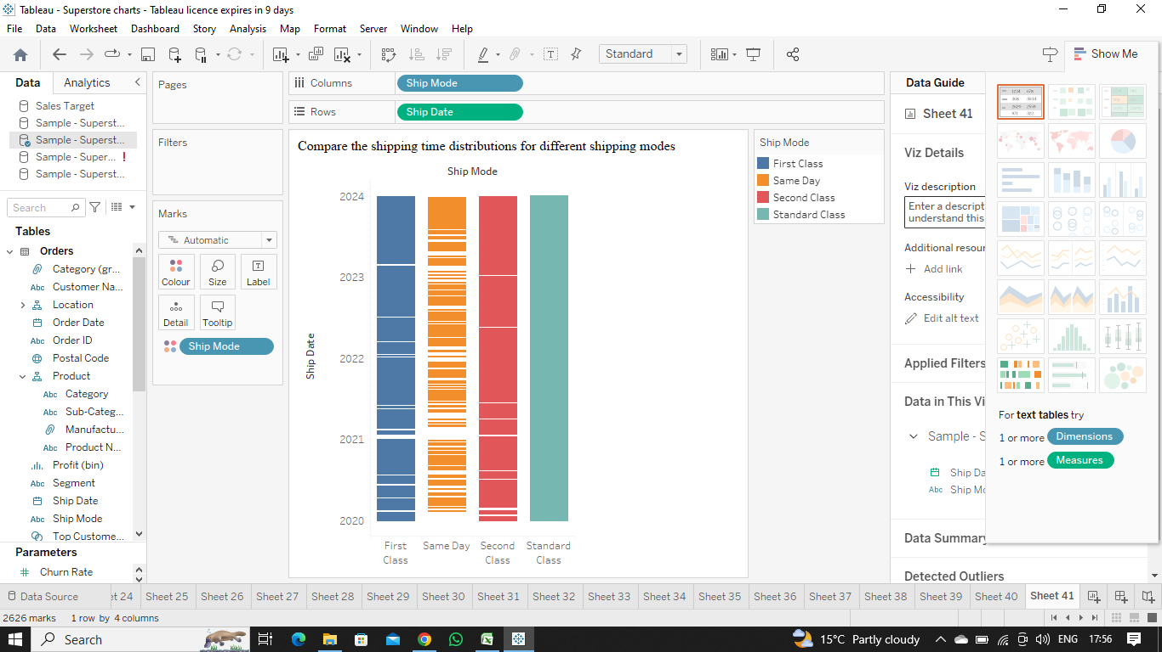  
      
    Explanation:-**To compare the shipping time distributions for different shipping modes the best fit chart is **Gantt Chart** because wherever there is need of timeline or schedule we always use gantt chart .
17. What is the monthly trend in the number of orders shipped?  
    **Ans.  
    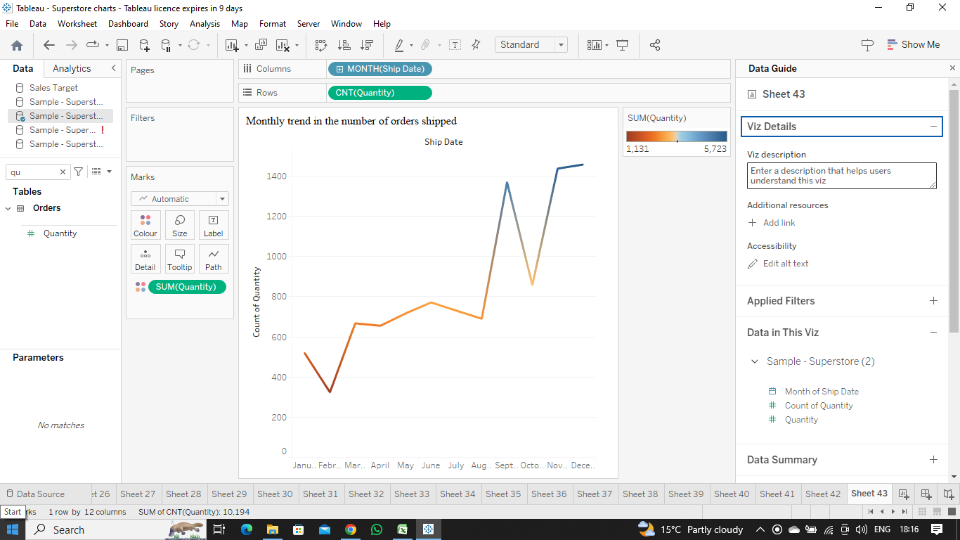  
      
    Explanation:-**As we know that to show the trend we use **Line Chart**Therefore, to show the monthly trend in the number of orders shipped we use a line chart .
18. How do different customer segments perform in terms of sales and discount rates?  
    **Ans.  
    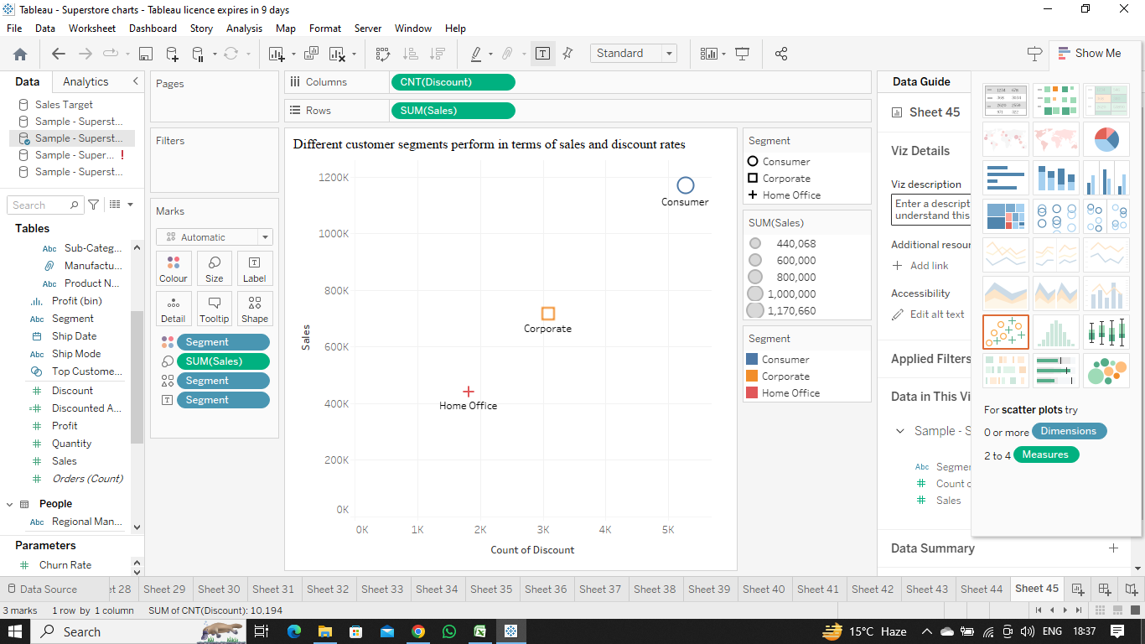  
      
    Explanation:-**As we know that to find relationship between two numerical values we always use **Scatter Chart**Therefore, to show different customer segments performing in terms of sales and discount rates we use a scatter chart .
19. What are the sales and profit trends across different product subcategories and regions in the Superstore dataset?  
    **Ans.  
    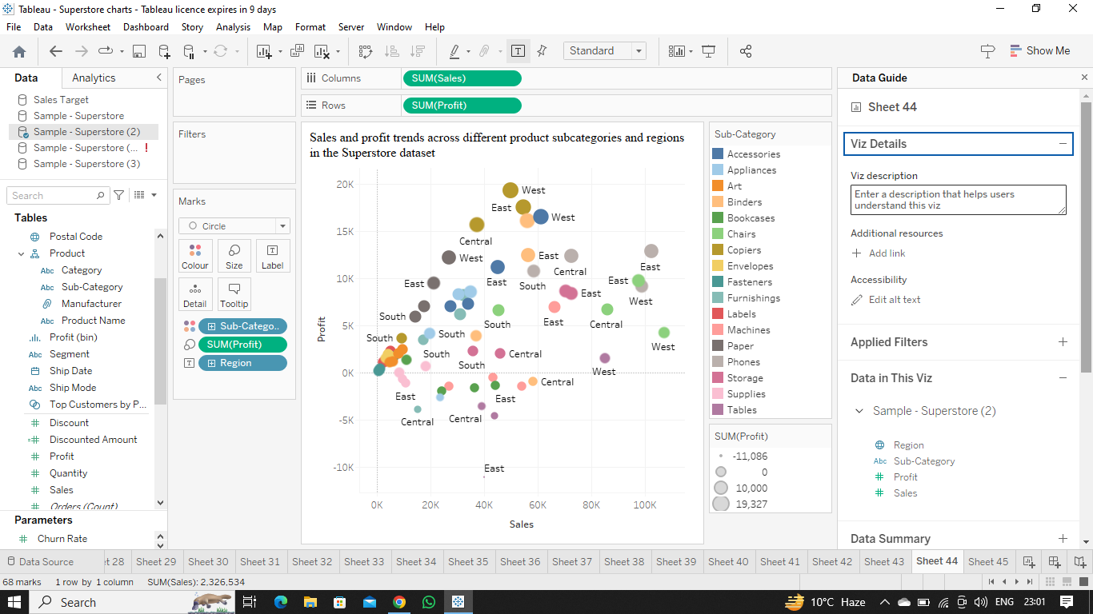  
      
    Explanation:-**To show the trend between two numerical values and their relationship we always use **Scatter Plots or Line Graph** .  
    Therefore , to show the sales and profit trends across different product subcategories and regions in the Superstore dataset we must use a scatter plot .
20. What is the average delivery duration for different regions and ship modes?  
    **Ans.   
    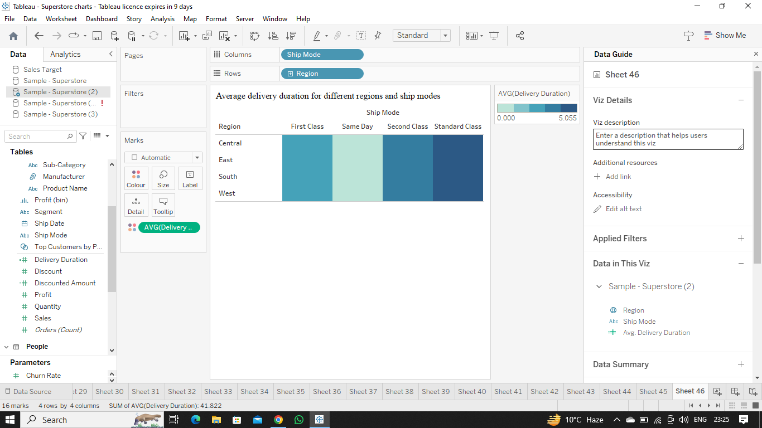  
      
    Explanation:-**To show the variation in a visualisation we always use **Heat Maps**Therefore , to show the average delivery duration for different regions and ship modes the best fit is a heat map .
21. How has the average order quantity changed over the years for various product categories?  
    **Ans.  
    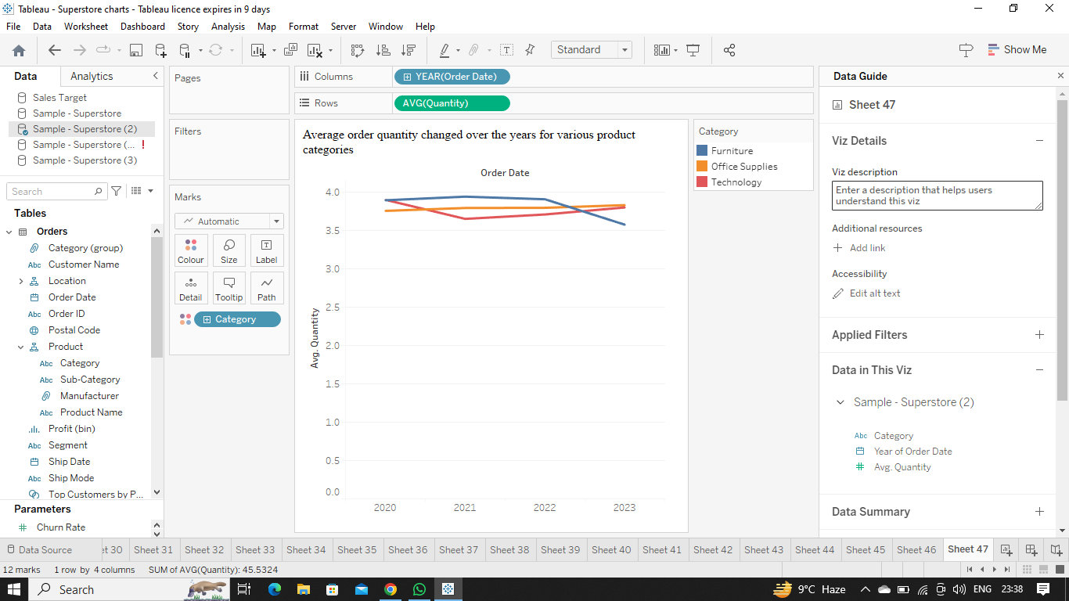  
      
    Explanation:-**As we know that to show the trend or change over the time we always use **Line graphs**So , to show the average order quantity changed over the years for various product categories the best fit is a line graph .
22. Can we visualise the correlation between discount rates and order quantities for different customer segments?  
    **Ans.   
    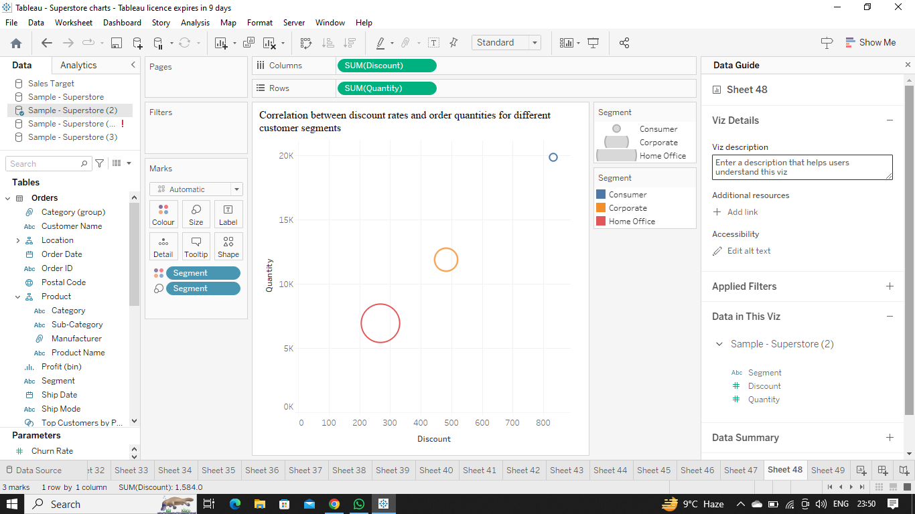  
      
    Explanation:-**To show the relationship between two numerical values we always use **Scatter plots**Therefore , to visualise the correlation between discount rates and order quantities for different customer segments the best fit is a scatter plot .
23. What is the proportion of orders returned in each region within the Superstore dataset?  
    **Ans.  
    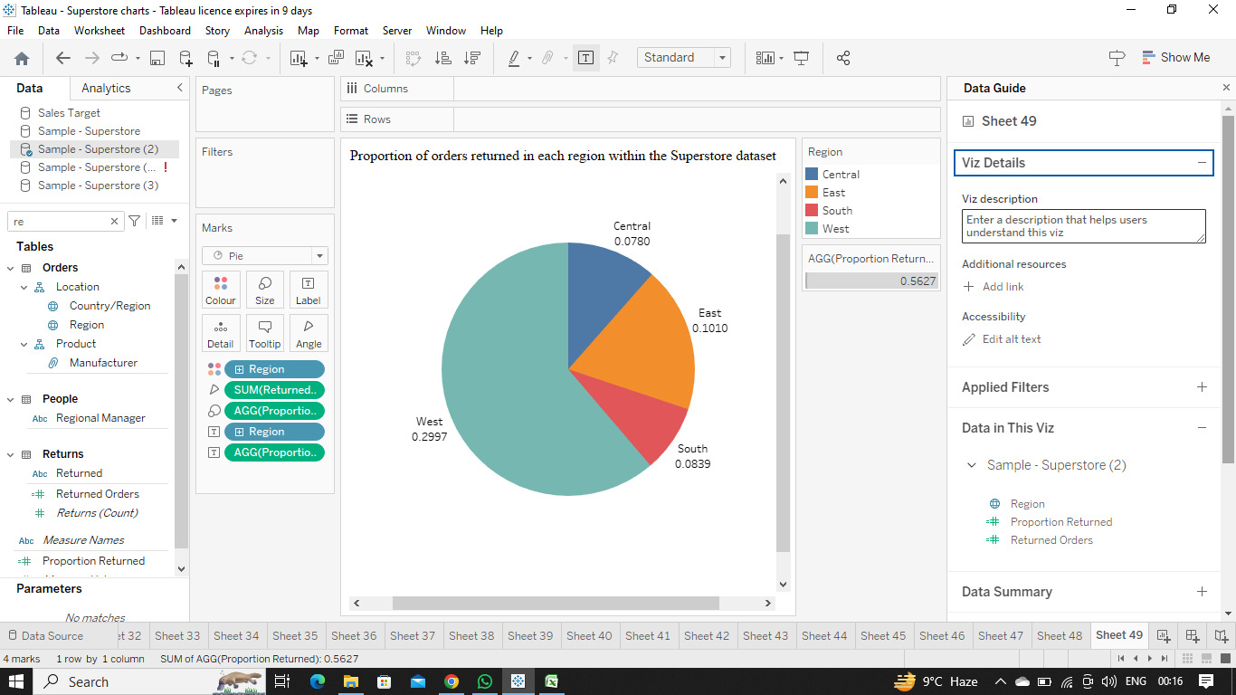  
      
    Explanation:-**To show the proportion or percentage in comparision of whole we always use **Pie Chart**Therefore , to show the proportion of orders returned in each region within the Superstore dataset the best fit chart is a pie chart .
24. Can you compare the profit of different products for different subcategories?  
    **Ans.   
    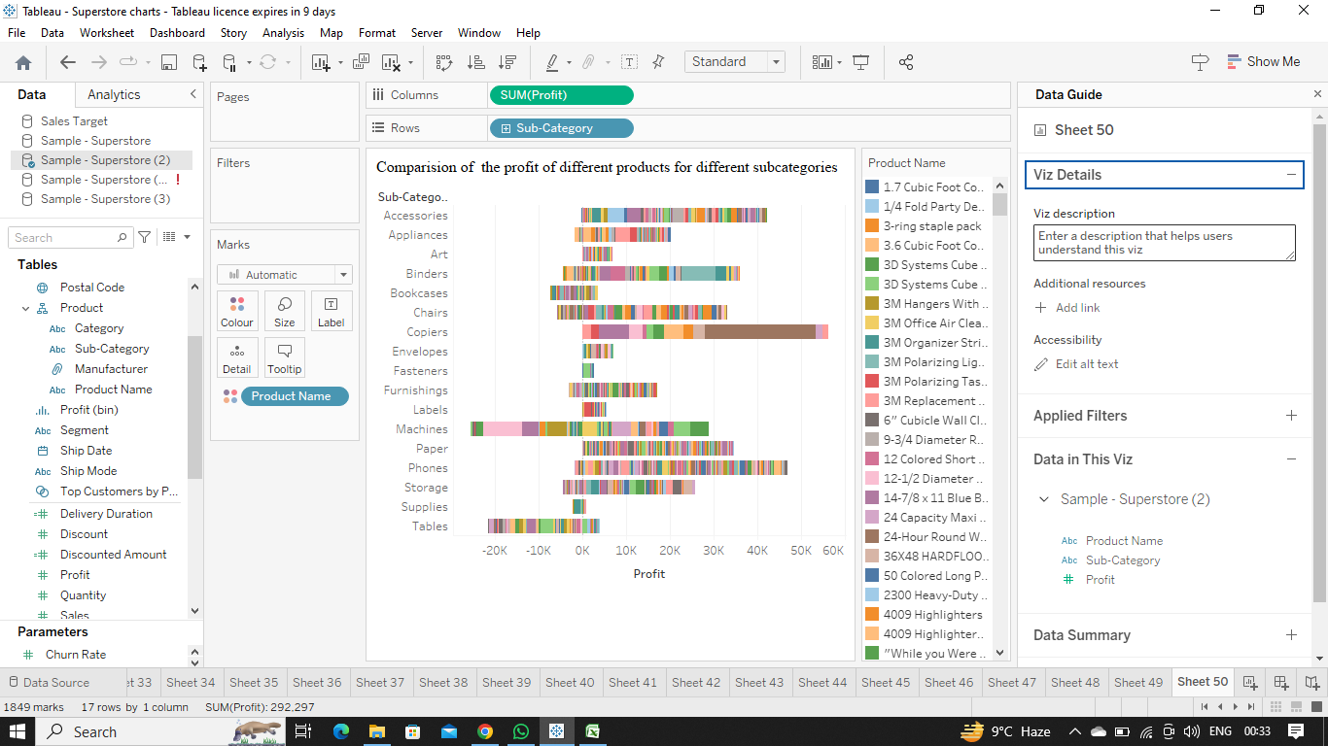  
      
    Explanation:-**For comparison we always use **Bar charts** so , to compare the profit of different products for different subcategories the best fit chart is always a bar chart .
25. Which shipping mode is the most commonly used in the Sample Superstore dataset?  
    **Ans.  
    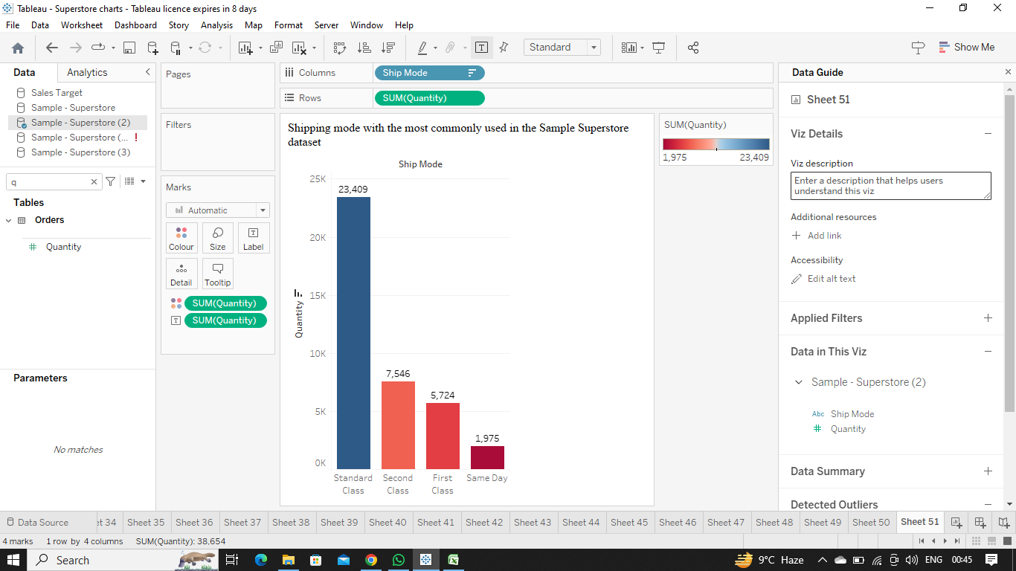  
      
    Explanation:-**For showing the most commonly used shipping mode in the Sample Superstore dataset we need to compare the total quantity of orders shipped through every ship mode and for that **Bar graph**  is the best fit .
26. How does the sales performance of different regions evolve throughout the quarters of a year?  
    **Ans.  
    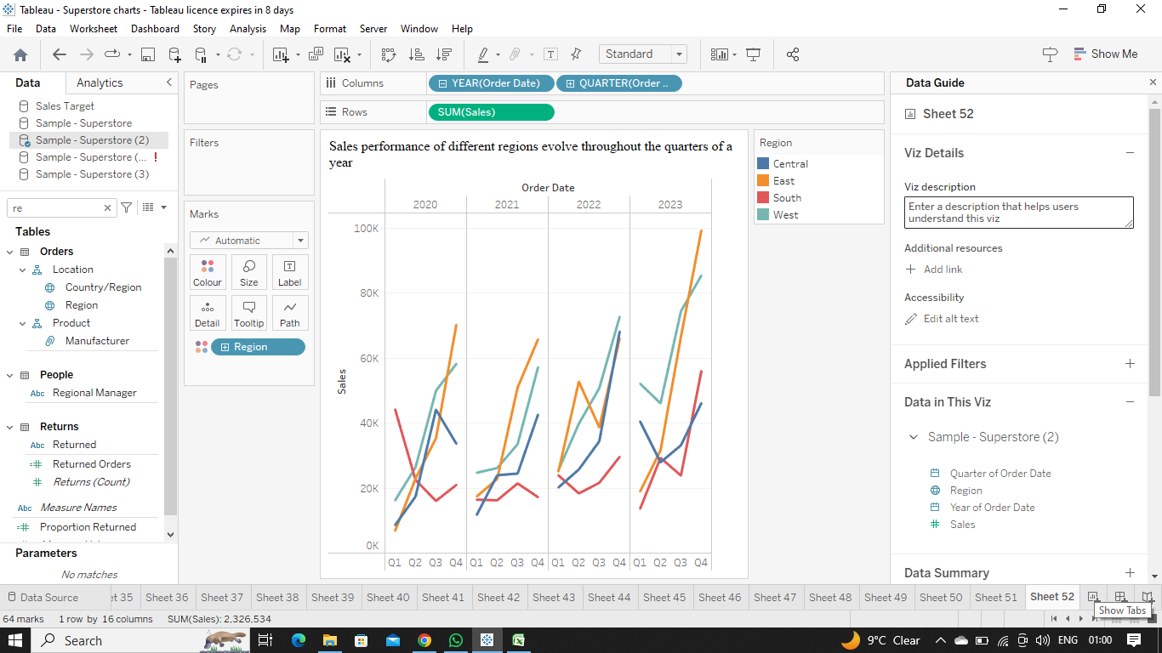  
      
    Explanation:-**To show the trend or evolution over the year we use **Line Graphs** so , to show the sales performance of different regions evolve throughout the quarters of a year the best fit graph is a line graph .
27. What is the distribution of order priorities across different product categories?  
    **Ans.  
    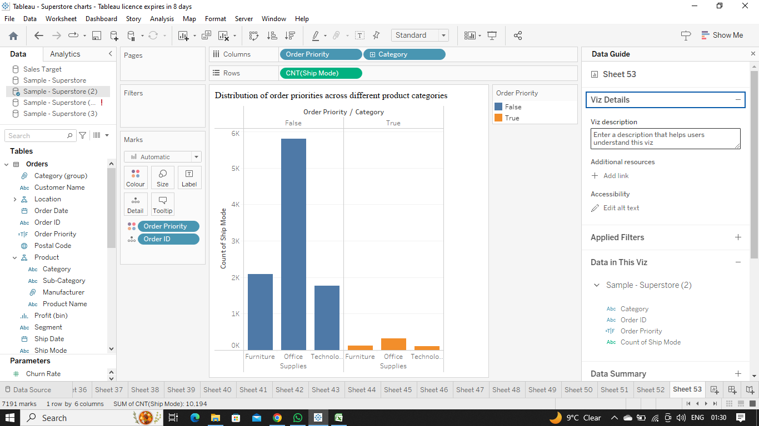  
      
    Explanation:-**  
    To do comparison we always use **Bar Graphs** so , to show the distribution of order priorities across different product categories we need to compare the priorities and therefore use a bar graph .
28. What is the relationship between discounts and sales?  
    **Ans.  
    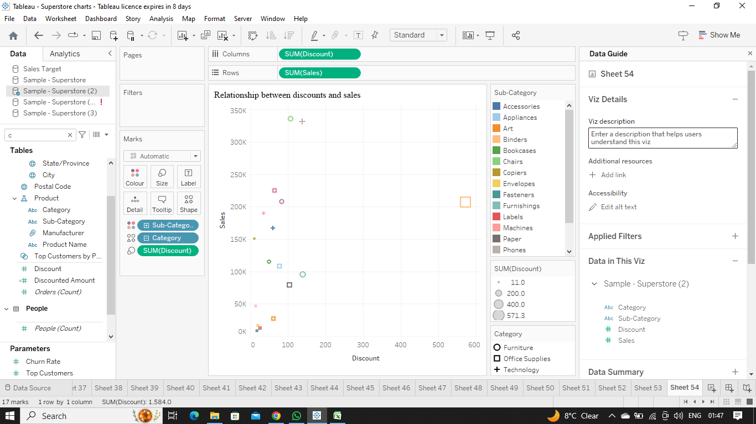  
      
    Explanation:-** To show the relationship between two numeric values we use **Scatter plots** so , to show the relationship between discounts and sales the best fit graph is a scatter plot .
29. How does the average order value differ between repeat customers and new customers?  
    **Ans.  
    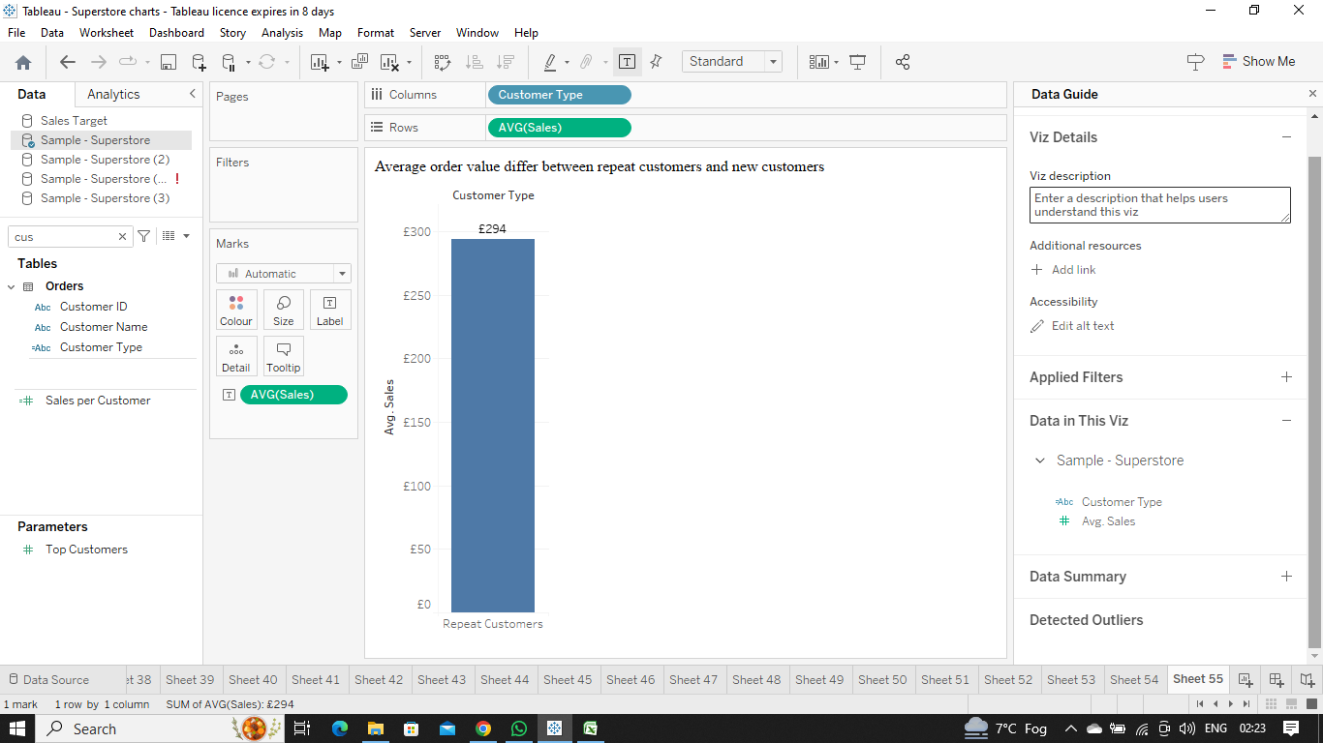  
      
    Explanation:-**To show the comparison we use **Bar Graphs** so , to show the average order value differs between repeat customers and new customers the best fit graph is a bar graph .
30. What is the geographical distribution of returns and its impact on overall profitability?  
    **Ans.  
    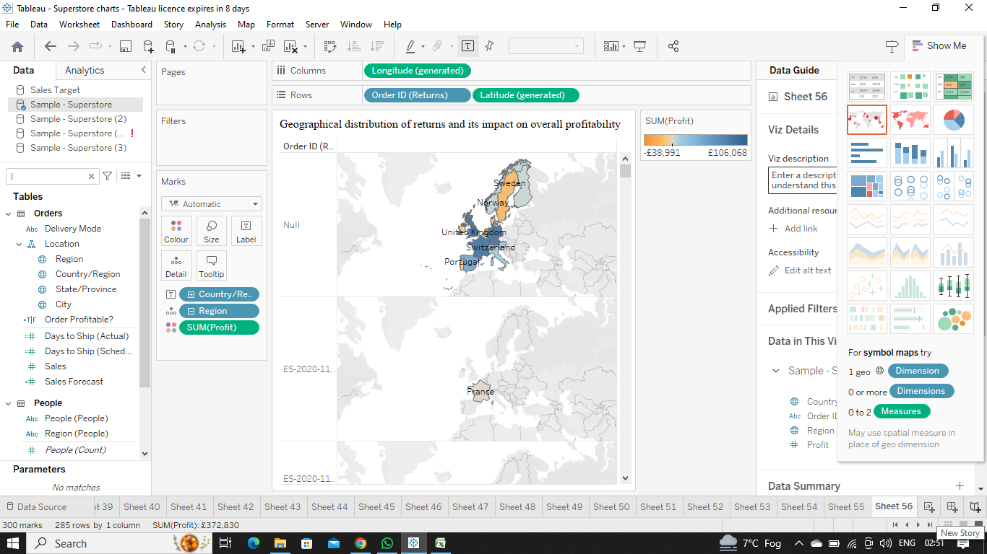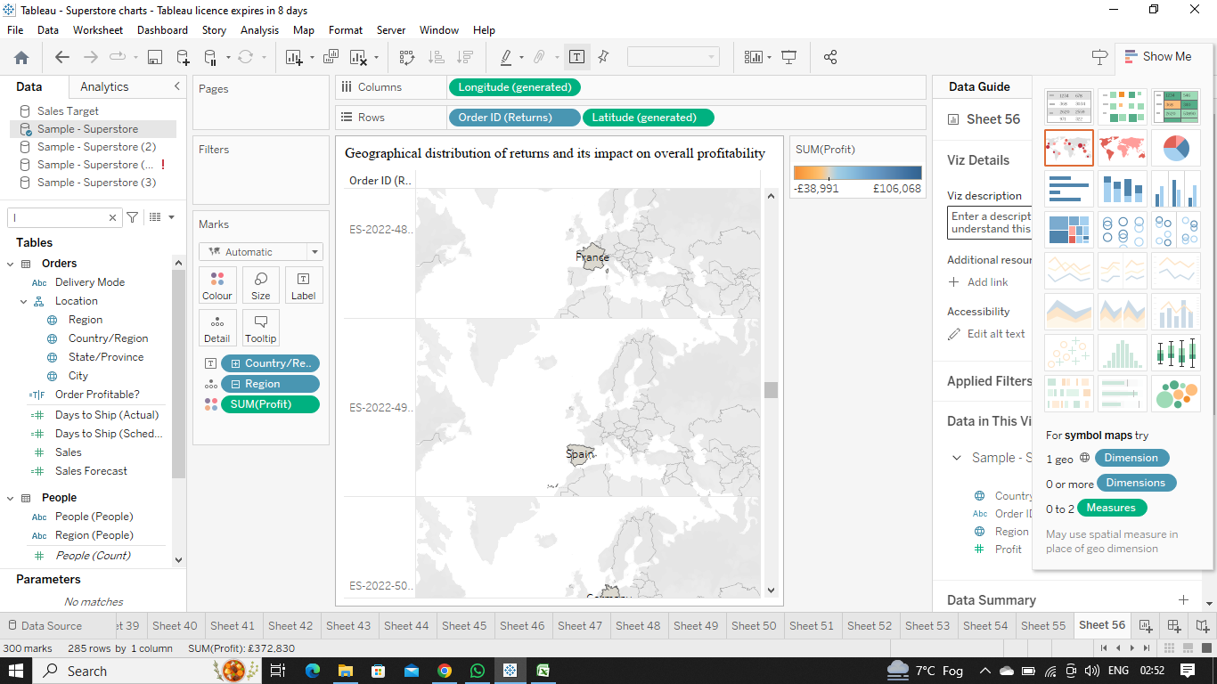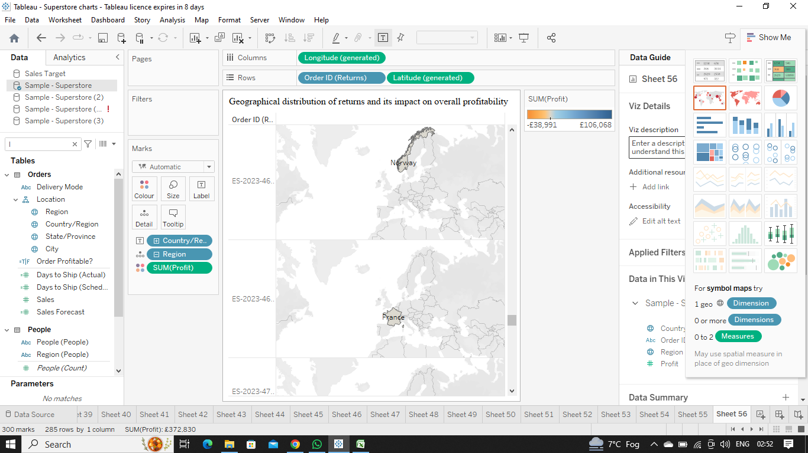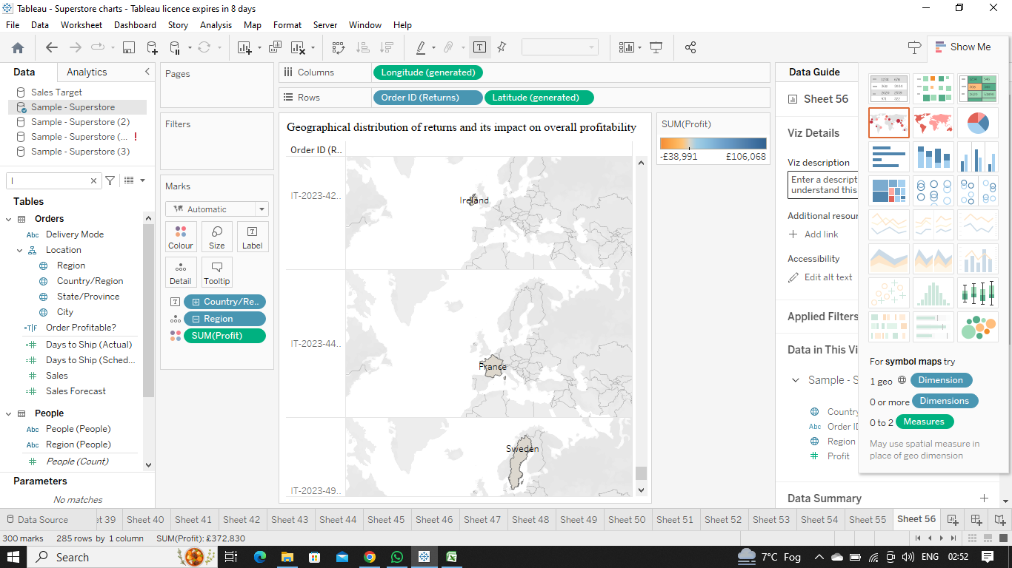  
      
    Explanation:-**When there is use of geographical representation of a large set of data we use **Symbol Maps** so , to show the geographical distribution of returns and its impact on overall profitability the best fit graph is a Symbol map .